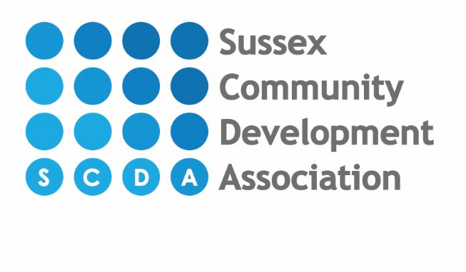
Standard fees as from January 2026 for 3 & 4 year old 15 hour & 30 hour funded children

Start times: End times:
8.00am 12.00pm
9.00am 1.00pm
1.00pm 3.00pm
4.00pm 5.00pm
6.00pm

Funded 3-4 year olds (Universal 15 hours funding code)
- Funded sessions will ONLY be offered during 1-4pm, with possible option of a 9-12 session(s) being offered if we have capacity and only for those using the universal 15 hours funding.
- For any additional private hours, they will be charged at the full hourly rate of £9.00. For children attending our breakfast club hour 8am-9am breakfast is included and for children attending our tea club hour 5pm-6pm tea will be included in the hourly rate.
- There will be a voluntary charge of £2.20 per day/per 3 hour funded session for the care package. A session is either 9am-12pm or 1pm-4pm. The care package charge covers: Sun cream, wipes, snacks at nursery, forest school and woodwork school. If this isn’t taken up parent is to provide their own sun cream, nappies and wipes for their child. Parents will be required no opt out of this if they do not wish for the nursery to charge and provide this.
- The universal 15 hours funding can be used either stretched across the full year or term time only. If a child stretches their funding to use it across the full year it works out to be 11.4 funded hours per week over 47 weeks of the year with 4 weeks unfunded where full fees will be charged. This is the current offer for stretched hours.
- Minimum of 2 sessions attended per week.

30 hour funding offer for working parents (3-4 year olds)
- Funding will be offered on a full year basis ONLY – this is a stretched offer.
- This will give all 30 hour code parents, 22.8 hours/week over 47 weeks of the year with 4 weeks unfunded where full fees will be charged. This is the current offer for stretched hours.
- Funded sessions will be offered during the hours of 9am-3pm.
- Any additional private hours will be charged at the full hourly rate of £9.00. For children attending our breakfast club which is 8am-9am breakfast is included and for children attending our tea club which is 5pm-6pm tea will be included in the hourly rate.
- There will be a voluntary charge of £4.40 per day/per 6 hour funded session for the care package or a voluntary charge of £2.20 per day/per session if only attending a 3-hour session (9am-12pm or 1pm-4pm). The care package charge covers: Sun cream, Wipes, snacks at nursery, forest school and woodwork school. If this isn’t taken up parent is to provide their own sun cream, nappies and wipes for their child. Parents will be required no opt out of this if they do not wish for the nursery to charge and provide this.
- Minimum of 2 sessions attended per week.

More than one child in your family? For families with more than one child attending the nursery, we give a reduction of 5% on the second child.
You may be entitled to Childcare Tax Credit or help towards nursery fees via Universal Credits - please speak to a member of staff.

THERE IS A ONE OFF REGISTRATION CHARGE OF £60 PAYABLE ON APPLICATION. NURSERY FEES ARE CHARGED IN ADVANCE AND THERE IS A REFUNDABLE DEPOSIT OF £80 TO BE PAID WITHIN 1 MONTH OF SUMITTING A NURSERY APPLICATION FORM FOR ANY FUNDED HOURS BOOKED WITH US. THIS WILL BE RETURNED AFTER 1 MONTHS ATTENDANCE AT NURSERY.
FOR CHILDREN ATTENDING PRIVATE HOURS WITH US OUTSIDE OF FUNDED HOURS THERE WILL BE A DEPOSIT CHARGED FOR FOUR WEEKS AGREED FEES BASED ON ANY PRIVATE SESSIONS BOOKED, THIS IS PAYABLE WITHIN A MONTH OF SUBIMITTING A NURSERY APPLICATION FORM (DEPOSIT WILL BE UPDATED IF YOU INCREASE YOUR HOURS.) THIS WILL BE RETURNED WHEN YOUR CHILD LEAVES THE NURSERY SETTING. ACTION WILL BE TAKEN AGAINST THOSE WHO DO NOT PAY THEIR FEES AS AGREED AND YOUR DEPOSIT WILL BE FORFEITED IF YOU DO NOT TAKE UP THE OFFERED PLACE, DO NOT GIVE ONE MONTHS NOTICE OR FOR ANY OUTSTANDING FEES ON LEAVING THE NURSERY.

