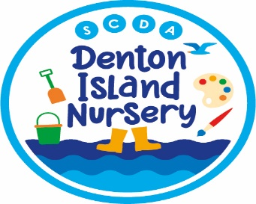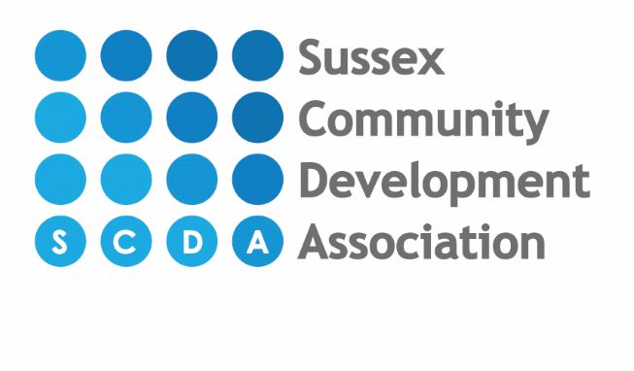

OPTIONAL EXTRAS CHARGES – CARE PACKAGE FOR 3&4 YEAR OLD CHILDREN ONLY

Please select which optional extra’s you wish to pay for. These will be charged as a daily charge. All parents are automatically opted in to these charged unless you choose to opt out below or select a different amount. If no selection is made, we will assume you are happy to stay opted in to these additional charges. If parents opt in they can choose to opt out at any time. For children under 3 years old these charges do not apply.

15 hours universal funded hours only either 9am-12pm or 1pm-4pm – Please circle or highlight relevant option
Food: (Morning &/or afternoon snack) Cost £1.10 per 3 hour funded session (either 9-12 or 1-4) Automatically opted in | YES - I am happy to stay opted in | NO - I wish to opt out of these charges | I wish to pay a different amount (please state how much you wish to pay):

Non-Food: Wipes, Sun cream, forest school & wood work school. Cost £1.10 per 3 hour funded session (either 9-12 or 1-4) Automatically opted in | YES - I am happy to stay opted in | NO - I wish to opt out of these charges | I wish to pay a different amount (please state how much you wish to pay):

30 hours funding for working parents between 9am-3pm or 1pm-4pm – Please circle or highlight relevant option
Food: (Morning &/or afternoon snack) Cost £1.10 per 3 hour funded session (either 9-12 or 1-4) or up to £2.20 per day if attending between 9am-3pm. Automatically opted in | YES - I am happy to stay opted in | NO - I wish to opt out of these charges | I wish to pay a different amount (please state how much you wish to pay):

Non-Food: Wipes, sun cream, forest school & wood work school. Cost £1.10 per 3 hour funded session (either 9-12 or 1-4) or up to £2.20 per day if attending between 9am-3pm. Automatically opted in | YES - I am happy to stay opted in | NO - I wish to opt out of these charges | I wish to pay a different amount (please state how much you wish to pay):

I have read the above information and understand and have selected my options. I understand that if no option is selected, I will automatically be opted in to additional food and non-food charges each day. (if this form is not completed you will atomically be opted in to additional charges – unless you opt out)

Child’s name:
Parents Name:
Please sign:
Date:

