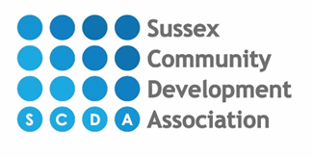 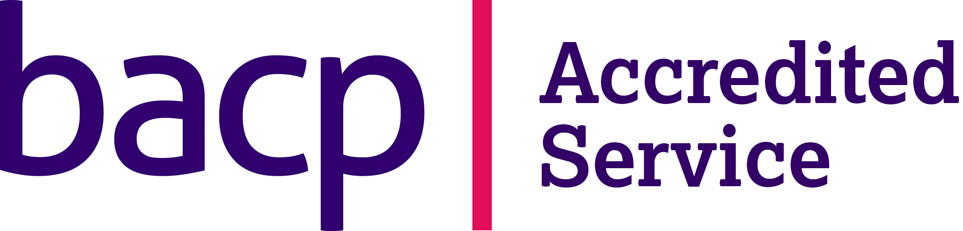

**Sussex Community Counselling Service**

Our fees for counselling sessions start at £25 per session up to £45 based on the following household income thresholds:

|  |  |
| --- | --- |
| **Household Income** | **Cost per session** |
| £25,000 or less | £25 |
| £25,000 or more | £30 |
| £35,000 or more | £35 |
| £45,000 or more | £45 |
|  |  |
| Specialised Counselling* | £45 |

All counselling fees are paid in advance of each session.

*Specialised counselling not covered by an existing funding programme and require a qualified, experienced counsellor.