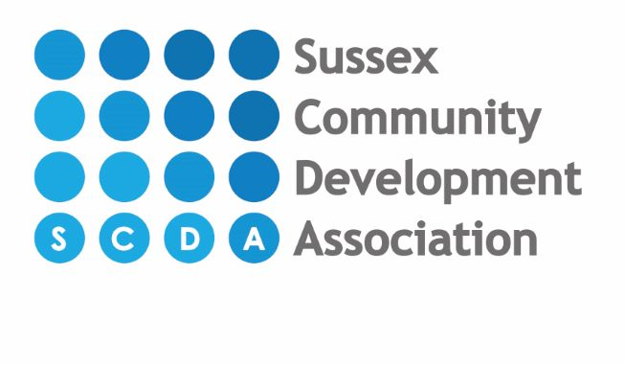
Standard fees as from February 2024 for 3 & 4 year old 15 hour & 30 hour funded children

Start times: End times:
8.00am 12.00pm
9.00am 1.00pm
1.00pm 3.00pm
4.00pm 5.00pm
6.00pm
Funded 3 year olds (15 hours)
- Funded sessions will ONLY be offered during 1-4pm, with possible option of a 9-12 session(s) being offered if we have capacity.
- Lunch hour (12-1pm) and any additional hours will be charged at the full hour rate of £7.20. For Children attending the breakfast hour 8am-9am breakfast is included and tea hour 5pm-6pm tea will be included in the hourly rate.
- There will also be a charge of £2.00 per session for the care package. A session is either 9am-12pm or 1pm-4pm. If a child attends both morning and afternoon (longer day) it would be £4 per day care package, plus lunch charge.
- We will continue to offer stretched or term time only offer for 15 funded children.
- Lunch charge would be £2.50 per day if attending past 1pm.
- If attending just 9am-1pm or 8am-1pm breakfast will still be charged at normal hourly fee and lunch also at normal hourly fee of £7.20.
- Breakfast 8am-9am & twilight session 4pm-5pm & 5pm-6pm is still charged at full hourly fee of £7.20 as these are the unfunded hours.
- The care package will cover our costs for wipes, sun cream, forest school sessions and snack.

30 hour funding (3 year olds)
- From September our new offer of funding will only be offered as a STRETCHED OFFER and no longer a term time only option.
- This will give all 30 hour code parents, 24 hours/week over 47 weeks of the year with 4 weeks unfunded where full fees will be required. This is the current offer for stretched hours.
- Funded sessions will be offered during 9-12pm and 1-4pm
- Breakfast (8-9am) and twilight sessions 4-6pm will be charged at the full hour rate of £7.20.
- There will also be a charge of £2.00 per session for the care package. A session is either 9am-12pm or 1pm-4pm. If a child attends both morning and afternoon (longer day) it would be £4 per day care package, plus lunch charge.
- Lunch charge would be £2.50 per day if attending past 1pm.
- If attending just 9am-1pm or 8am-1pm breakfast will still be charged at normal hourly fee and lunch also at normal hourly fee of £7.20.
- The care package will cover our costs for wipes, sun cream, forest school sessions and snack.
- More than one child in your family? For families with more than one child attending the nursery, we give a reduction of 5% on the second child.
- You may be entitled to Childcare Tax Credit or help towards nursery fees via Universal Credits - please speak to a member of staff.

THERE IS A ONE OFF REGISTRATION CHARGE OF £50 PAYABLE ON APPLICATION. NURSERY FEES ARE CHARGED IN ADVANCE AND THERE IS A REFUNDABLE DEPOSIT OF FOUR WEEKS AGREED FEES PAYABLE AT THE SECOND SETTLE SESSION (DEPOSIT WILL BE UPDATED IF YOU INCREASE YOUR HOURS.) ACTION WILL BE TAKEN AGAINST THOSE WHO DO NOT PAY THEIR FEES AS AGREED AND YOUR DEPOSIT WILL BE FORFEITED IF YOU DO NOT TAKE UP THE OFFERED PLACE, DO NOT GIVE ONE MONTHS NOTICE OR FOR ANY OUTSTANDING FEES ON LEAVING THE NURSERY.

3-4 Year old FREE option for funding – Limited availability

- Term Time attendance only (38 weeks)
- Up to 15 hours funding a week
- Sessions available will be 1pm-4pm Monday to Friday
- Parent to provide sun cream, nappies and wipes for their child
- Includes afternoon snack
- Additional hours charged at normal hourly rate and must be paid in advance of attending
- Minimum of 2 sessions attended per week

