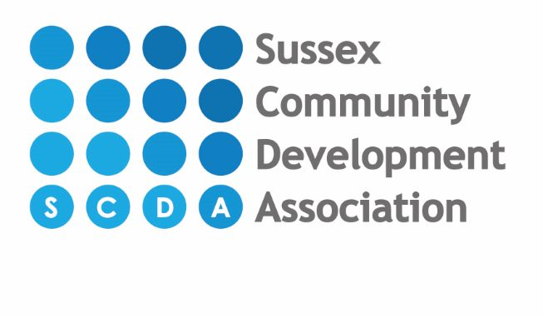

Costs breakdown from February 2024 per day for 3 & 4 year old funded children

8am-12pm = £9.20
8am-1pm = £16.40
8am-3pm = 13.70
8am-4pm = £13.70
8am-5pm = £20.90
8am-6pm = £28.10
9am-12pm = £2.00
9am-1pm = £9.50
9am-3pm = £6.50
9am-4pm = £6.50
9am-5pm = £13.70
9am-6pm = £20.90
1pm-4pm = £2.00
1pm-5pm = £9.50
1pm-6pm = £16.40

