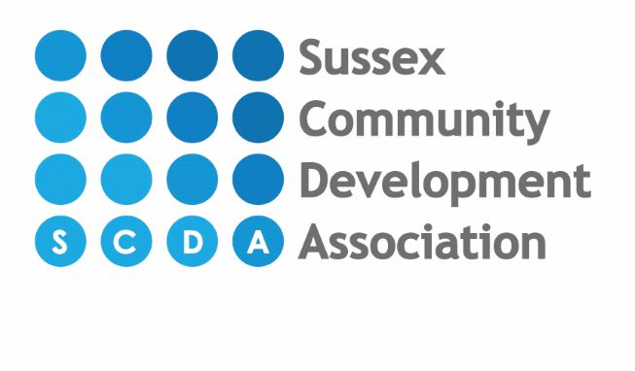
Standard fees as from September 2023
(Subject to possible increase from April 2024)

CHILDREN AGED 3 MONTHS- 2 YEARS
£7.20 PER HOUR

Start times: End times:
8.00am 12.00pm
9.00am 1.00pm
1.00pm 3.00pm
4.00pm 5.00pm
6.00pm

Meal charges-Breakfast & Tea £2.00 each, Packed lunch supervision £0.25p.

Healthy snacks are provided during the day free of charge, e.g. fresh fruit, raisins and other dried fruit.

3 month old – 2 year old places are offered on a Full Year attendance basis only.
More than one child in your family? For families with more than one child attending the nursery, we give a reduction of 5% on the second child.
You may be entitled to Childcare Tax Credit or help towards nursery fees via Universal Credits - please speak to a member of staff.

THERE IS A ONE OFF REGISTRATION CHARGE OF £50 PAYABLE ON APPLICATION. NURSERY FEES ARE CHARGED IN ADVANCE AND THERE IS A REFUNDABLE DEPOSIT OF FOUR WEEKS AGREED FEES PAYABLE AT THE SECOND SETTLE SESSION (DEPOSIT WILL BE UPDATED IF YOU INCREASE YOUR HOURS.) ACTION WILL BE TAKEN AGAINST THOSE WHO DO NOT PAY THEIR FEES AS AGREED AND YOUR DEPOSIT WILL BE FORFEITED IF YOU DO NOT TAKE UP THE OFFERED PLACE, DO NOT GIVE ONE MONTHS NOTICE OR FOR ANY OUTSTANDING FEES ON LEAVING THE NURSERY.

