 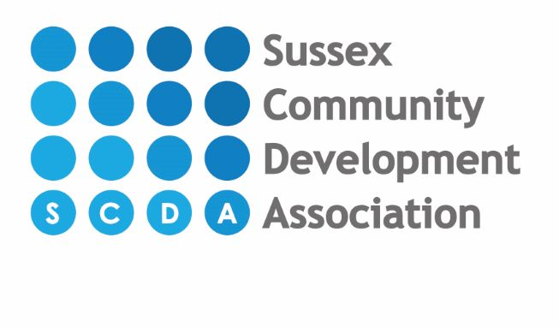

**Costs breakdown from September 2023 per day for 3 & 4 year old funded children**

**8am-12pm =** £11.70

**8am-1pm =** £18.90

**8am-3pm =** £21.90

**8am-4pm =** £23.40

**8am-5pm =** £30.60

**8am-6pm =** £37.80

**9am-12pm =** £4.50

**9am-1pm =** £11.70

**9am-3pm =** £14.70

**9am-4pm =** £16.20

**9am-5pm =** £23.40

**9am-6pm =** £30.60

**1pm-4pm =** £4.50

**1pm-5pm =** £11.70

**1pm-6pm =** £18.90