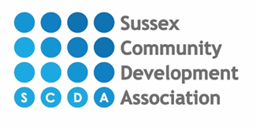

Sussex Community Counselling Service
Our fees for counselling sessions start at £20 per session up to £45 based on the following household income thresholds:
Household Income | Cost per session
£25,000 or less | £20
£25,000 or more | £25
£35,000 or more | £35
£45,000 or more | £45

All counselling sessions require payment before each session.

