Volunteer Application form
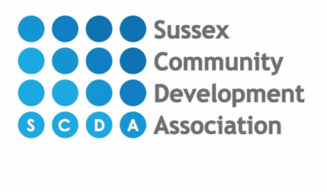

If you need any assistance filling in this form please ask

VOLUNTEER ROLE
What role are you interested in?  Please tick all that apply | Community supermarket
 | Delivery driver
 | Community kitchen
 | Storeroom
 | Social media
 | Retail shops
 | Admin
Location  Please tick all that apply: | Newhaven
 | Peacehaven
 | Eastbourne
How did you hear about this opportunity?

PERSONAL DETAILS
First Name:

Surname:

Pronoun (i.e he/she/they)
Title (Mr/Mrs/Miss/Ms/Mx):
Address:
Post code:
Home telephone number:
Mobile telephone number:
E-mail address:

Please give a brief outline of why you wish to volunteer and what experience(s) you can bring to the organisation:

REFERENCES
To assist us in offering you this opportunity we would ask you to give us the names of two references could contact to provide us with character references

Name: | Address & email address:

AVAILABILITY

SCDA value its volunteers and any of your valuable time that you give to us as a volunteer. We would grateful if you could give us an idea of your availability on the forms bellow

Days of the week | AM | PM
Monday
Tuesday
Wednesday
Thursday
Friday

I would like to volunteer….
Weekly
Fortnightly
Monthly

Do you need any assistance or adaptions to be able to do the role Yes No

If Yes please state:

EMERGENCY CONTACT

Please provide us with contact details of someone who we might contact in an emergency:

Name:
Relationship to you
Address
Home Telephone

PERMISSIONS

☐ I am happy to be added to the volunteer email mailing list

☐ I am happy for my email to be used to register me on the online training portal iHasco

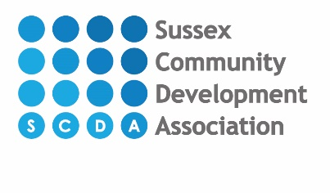

Monitoring Form for Equal Opportunities
Information for volunteers

Why monitor?
Without monitoring, an organisation will never know whether its equal opportunities policy is working. To have an equality policy without monitoring is like aiming for good financial management without keeping financial records.

Monitoring can tell an organisation whether it is offering equality of opportunity and treatment to all. It can also tell an organisation how and why it is falling short of this ideal. The organisation can then concentrate on finding solutions and making changes, rather than using guesswork or assumptions.

Categories for ethnic monitoring
We use the same ethnicity classification as the 2016 census so that comparisons can be made with census output data.

Why monitor age, disability, sexual orientation or gender?
To assist us with ensuring that our policies and practice, in relation to volunteer recruitment and selection, do not discriminate unfairly on the basis of protected characteristics outlined in the Equality Act 2010.

How will the information be used?
We will use the information gained to highlight possible inequalities and assist us with investigating their underlying causes and, removing any unfairness or disadvantage. The information gathered will also allow us to analyse how our practices and procedures affect different groups.

Confidentiality
The Data Protection Act 1998 states that the racial or ethnic origin, sexual orientation, religion etc of an individual is 'sensitive personal data.' This means that the information you reveal about yourself will not be disclosed, other than as part of the generic ethnic monitoring statistics which the organisation undertakes. The information will be used for the practical purposes already stated.

Please return this form......
To the same address as your application form. The form will be processed separately to your application form.

If you have any comments.....
On the information provided here or on any other aspect of our monitoring process please write HR at Denton Island Community Centre, Newhaven BN9 9BN.

What is your ethnic group?

Please read the Monitoring Form - Information for volunteers which accompanies this form. We hope you will want to complete this form.

Choose ONE section from A to E, then tick the appropriate box to indicate your cultural background.
A WHITE

British |  |  |  |  |  | Any other please write in • eg. Polish and Greek
Irish
Gypsy or Irish Traveller
B MIXED

White and Black Caribbean |  |  |  |  |  |  |  |  |  | Any other Mixed background please write in
White and Black African
White and Asian
C ASIAN OR ASIAN BRITISH

Indian |  |  |  |  |  |  | Any other Asian background please write in – eg. Korean and Japanese
Pakistani
Bangladeshi
Chinese
D BLACK OR BLACK BRITISH

Caribbean |  |  |  |  |  |  | Any other Black background please write in – eg. Black American and Black European
African
E OTHER ETHNIC GROUP

Arab |  |  |  |  |  |  | Any other please write in – eg Polynesian and Melanesian

Other Monitoring

Do you consider yourself as having a disability?
Yes No Prefer not to state

N.B. Definition of disability under the Equality Act 2010. You're disabled under the Equality Act 2010 if you have a physical or mental impairment that has a 'substantial' and 'long-term' negative effect on your ability to do normal daily activities.

Gender Identity

Do you identify as: Male Female Non-binary
Unsure Prefer not to state Prefer to self-describe:_________________

Does your gender identity match the sex you were assigned at birth (born as)?

Yes No Some of the time Unsure Prefer not to say

Age

How old are you?

Sexuality

Are you: Bisexual Gay Heterosexual/ Straight
Lesbian Unsure Prefer not to state

Prefer to self-describe:_______________________

___________________________________________________________________

