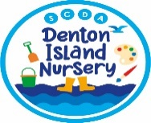
Thirsty children – choosing the right drink
Government health advice recommends young children should only drink milk or water.
Why is this?
The overall problem is that these drinks contain a lot of sugar. Drinking and eating too much sugar has lots of health risks and leads to tooth-decay.
Also, when we drink sweet things, we like the sweetness and unsweetened things taste unpleasant. This makes us want to eat and drink more sweet things getting us stuck in a cycle of eating sweet foods – which usually have very little in the way of vitamins and minerals.
The good news is that if we eat natural foods and drink without all the added sugars and sweeteners healthy foods actually taste better to us! So, if you are struggling to get your child to eat their vegetables reducing the amount of sugar they eat, and drink will really help.
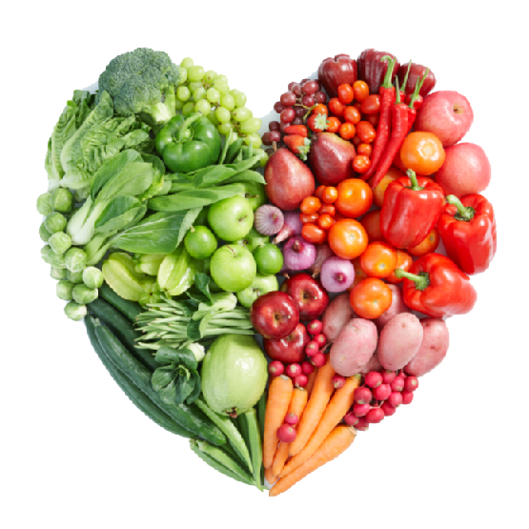
Below is some more information about each kind of drink and how they government advice fits in. We have also included advice on switching your child gradually onto water and milk if they are used to only sweetened options.
This Photo by Unknown Author is licensed under CC BY-NC
Squash drinks
Fruit squash drinks (that you dilute or buy ready mixed) are high in sugars or contain artificial sweeteners that encourage a ‘sweet tooth’, in addition some nutritionists have expressed health concerns over some artificial sweeteners.
For example, a carton of Ribena has 4 ½ spoons of sugar in it and orange squash has 2 ½ spoons of sugar per glass.
Squashes are also low in nutrients making them far from an ideal choice from the perspective of healthy eating. Drinking squashes between meals, like juice, is damaging for children’s teeth.
Fizzy drinks
The advice is that pre-school age children should not be given fizzy drinks at all due to the high sugar content and in the case of colas the caffeine content.
Pure fruit juice
Pure fruit juices are high in sugar, but they also contain vitamins and are a source of fibre. The advice recommends that if you choose to give your children fruit juice you should offer pure fruit juices, diluted with two parts water, at mealtimes. This is because drinking juices between meals can damage children’s teeth. It is also recommended that children drink no more than 150ml (5floz) of juice a day.
Smoothies
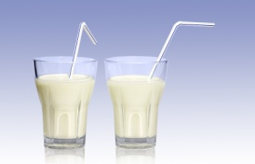
Fruit smoothies are also very high in sugars and sweeteners and pose the same problems to healthy eating as pure fruit juices. Some fruit smoothies have 3 ½ spoons of sugar per carton.
A Sweet tooth
When we are used to drinking sweet-flavoured drinks non-sweetened drinks like water and milk will taste unpleasant or unfavourable at first. Any of us who have cut down how many sugars we add to our tea or coffee know it takes a while before it tastes ‘right’ to us. But persevere and it will happen.
Help! My child will only drink juice
If you are finding it difficult to change to your child drinking water or milk between meals here are a few tips you could try:
- If your child dislikes plain milk you could a home-made smoothie; try blending milk with soft fruit like banana, strawberries, or mango. Slowly reduce the amount of fruit you add to allow your child to get used to the taste of plain milk.
- If you are using squashes switch to pure fruit juices and water it down,
- Restrict squashes, juices and smoothies to meals times to limit the risk of tooth decay and acid erosion,
- Begin to dilute the pure fruit juice you give to your child,
- Gradually reduce the amount of juice you put in your child’s cup over the week so that eventually there is barely any juice added to the water, this way your child gets used to the taste of water slowly,
- Avoid having the juice on show and show your child a good example by drinking milk or water yourself,
- Continue to offer your child only milk or water as a drink option and only give juice if your child asks for it,
- Use positive associations, (e.g. ‘Batman drinks all his milk to become big and strong’, ‘Elsa loves to drink water’ etc...)
- Be patient, it may take a few weeks of using the tips above before your child accepts milk or water as a drink, but if you stay consistent and positive, you will get there.
If you need more help please come and speak to a member of staff.

