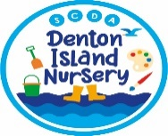
Tips to support your child to eat well
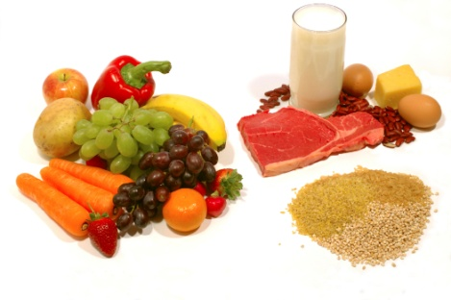
Young children develop many food preferences while they are toddlers but it’s not too late to introduce new foods and help your child develop table manners.
Here are some tips from the experts to help support you achieve happy mealtimes: -
- Stock the cupboards with healthy foods, your child will learn to ask for what they know is in the cupboard; remember as a parent/carer you are the one that controls what you buy and what choices you offer your child to eat.
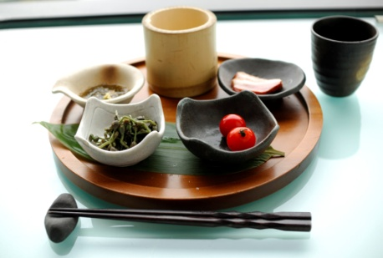
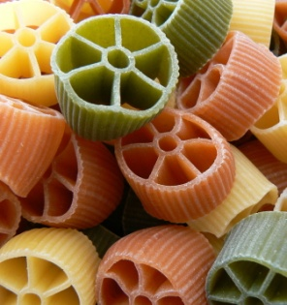
- Serve small portions, your child can always ask for more – start with a couple of tablespoons of a main meal and use the rule of thumb that a portion of each vegetable or fruit should fit into the palm of your child’s hand.
- Offer your child a variety of foods even if they have rejected the foods in the past, experts agree it can take 10 to 15 tries before a child accepts a new food and remember that ‘food fads’ usually don ‘t last long especially if you don’t give in to them
- Involve your child in food preparation – let them help tear up lettuce, wash the fruit, lay the table or fill up their wrap
- Have a structure for meal and snack times – this will mean your child does not ‘graze’ all day
- Have regular family meals and ensure these are pleasant social time for talking about the day or things to come
- Set a good example – your child is much more likely to make healthy choices if they see you eating nutritious foods too.
- Make the food look appealing – make faces with fruits or vegetables; arrange slices into flower shapes or use cutters and moulds to make food more fun.
- Teach your child to say, ‘no thank you’ instead of ‘yuck!’ help them learn how to use utensils, remind them to sit up straight at the table and support the to understand the table rules in your home
- Talk about why we eat – to ‘fuel’ our bodies, and give us energy to play, explain good foods help keep our bodies healthy, and some foods are just treats for now and then.
In addition to these tips there are a few things to avoid doing: -
- Don’t use food as a reward – it is better for children to learn that food is to help kept their bodies healthy and to give them energy to play than something they get for being ‘good’
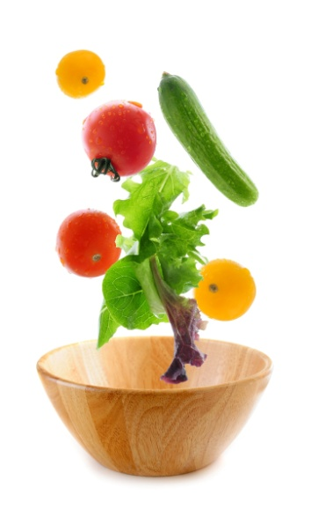
- Don’t make deals for eating, especially ones where pudding is offered as a reward for ‘eating all your broccoli’ – doing this can send the message that puddings are more valuable than healthy foods. Dealing over the number of bites can also lead to eating becoming a stressful negotiation instead of a relaxed and social event
- Don’t ‘talk up’ healthy foods too much by celebrating each mouthful of a healthy food eaten. Instead help children understand what the benefits are of eating healthily
- Don’t force your child to eat or bribe them to do so – this will cause more problems than it solves, if your child refuses to eat something try to stay relaxed and just try again the next time
- Avoid withholding pudding or using it as a reward – this tend to make children see puddings as special fantastic foods. Instead choose a pudding that is part of their eat-well meal, not the sweet-treat reward for eating all the ‘yukky veg’ first.

Be reassured experts agree that your child will not starve themselves. Being hungry on occasion is not a bad thing, it helps children to link that ‘tummy-ache’ feeling with needing to eat helping them understand what eating is for.

If you want more tips, trick meal or lunch box recipes have a look on these sites:
https://www.phunkyfoods.co.uk/recipes/
https://www.henry.org.uk/recipes
https://www.nhs.uk/change4life

