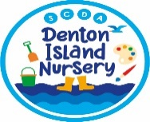Idea’s for lunch box treats

C:\Users\Michelle Reid\AppData\Local\Microsoft\Windows\Temporary Internet Files\Content.IE5\1KLU3GXW\MC900340486[1].wmfAs part of our Healthy lunch Box Policy, we ask all nursery families not to include sweets and chocolate bars in their child’s lunch box as they have no nutritional value and can discourage other children from eating the healthy options in their own lunch boxes.

Here are some ideas of additional items to include alongside a nutritionally balanced lunch box as a little something special;

* A tea cake or hot-cross bun
* Some slices of or fun-sized malt-loaf, fruit-loaf or Banana bread
* A scone or waffle
* Some home-made sugar free jelly with fruit pieces and natural fruit juice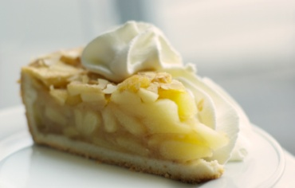
* A small slice of carrot cake or fruit cake
* Cinnamon bagel
* Oatcake
* Flapjack or small brownie
* 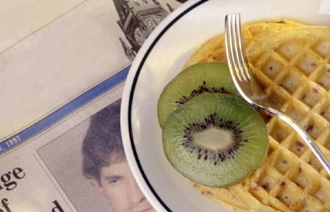Oat or digestive biscuits, or a chocolate chip cookie
* A small homemade fairy cake
* a slice of chocolate marble bread
* a small apple, cherry or fruit pie or serving of crumble
* a fun-size chocolate coated biscuit bar
* a pot of yoghurt (to keep costs down buy the big pots and decant into a small Tupperware pot)

Serving these items towards the end of the meal will also help protect teeth.