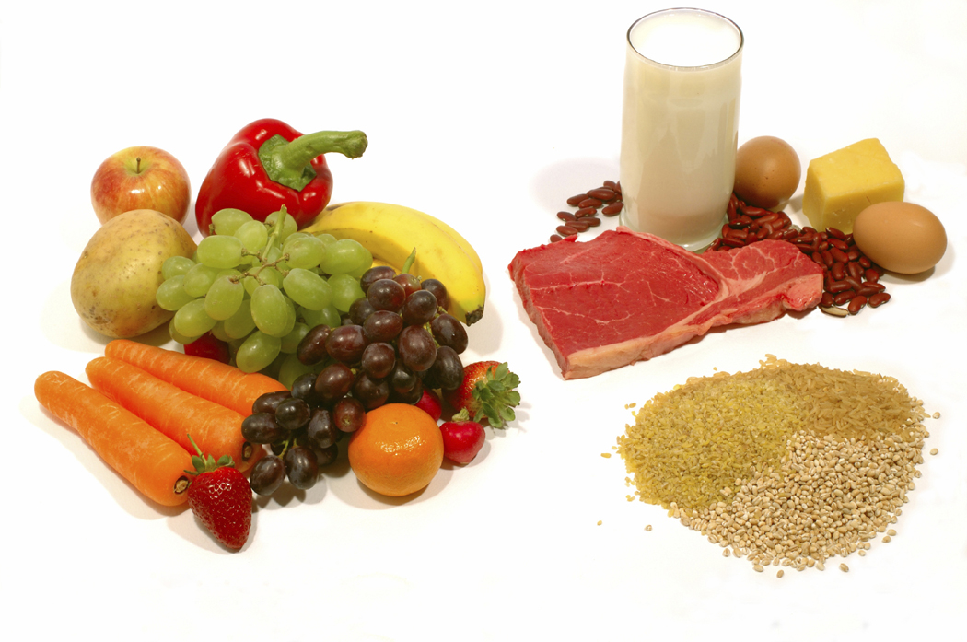
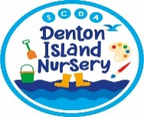
Healthy lunch box ideas for children under the age 5

Denton Island Nursery is dedicated to offering healthy, balanced, and nutritious foods and are proud to be part of the Healthy Active Little Ones Award. We have been awarded the Children’s Food Trust’s Outstanding Food Award.

To support our nursery families, we have researched and collected from various nutritional guidance sources a selection of ideas to help you provide a healthy lunch box for your child (once they have moved on from the weaning stage)
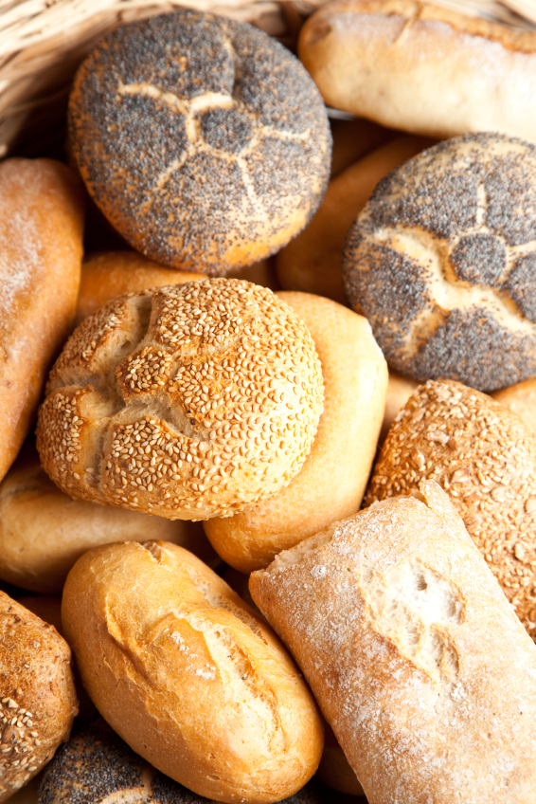
A nutritious Lunch box should include:

- A portion of starchy food – like bread, a roll, tortilla wrap, pitta bread, bagel, potatoes, rice, pasta, cous cous.

- A portion of meat, fish, eggs, or beans – for example offering cold pizza slices, sausage roll, mini pasty, samosa, pakora, or a mini quiche or as part of a rice, pasta, or bean salad, or as a sandwich, roll or wrap filling.

Here are some ideas of what you might choose.

- Wafer-thin cooked meats
- Cubed chicken or turkey breast with tomatoes and lettuce
- Ham and cheese
- Chicken and mashed avocado
- Tuna mayo and sweetcorn
- Sardine and tomatoes (make sure you buy the tins without bones)
- Fish paste and cucumber
- Grated cheese
- Quorn slices and salad
- Cheese and grated carrot with a little mayo
- Cottage cheese with pineapple
- Egg salad/ egg mayo
- hardboiled egg and cress,
- tuna and cucumber,
- sausage and tomato,
- ham and pineapple,
- hummus and grated carrot

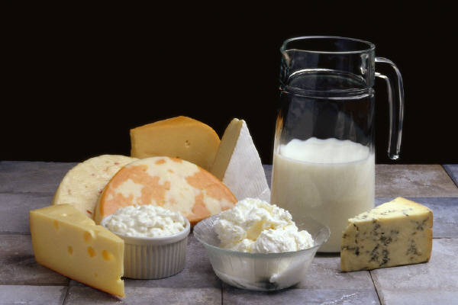
- A portion of dairy food – like milk, a fruit-based yoghurt or fromage frais, a portion of cheese, rice pudding or custard pot

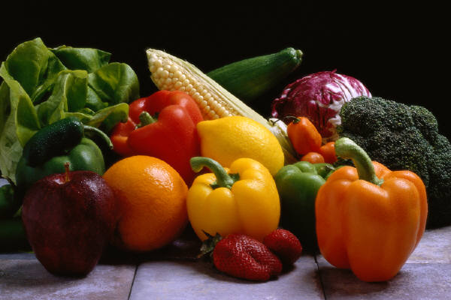
- Some fruits and vegetables – like a portion of fresh or dried fruit (raisins and other dried fruit are often high in sugar and are therefore better to be given at mealtimes rather than as a snack), or tinned fruit drained of natural juice, or a fruit pot, you could add raw vegetable sticks (perhaps with dips like hummus, tzatziki, cream cheese or plain yoghurt) or a salad pot

- A drink – water or milk, (we provide water with all meals and through the day and provide milk with snack)
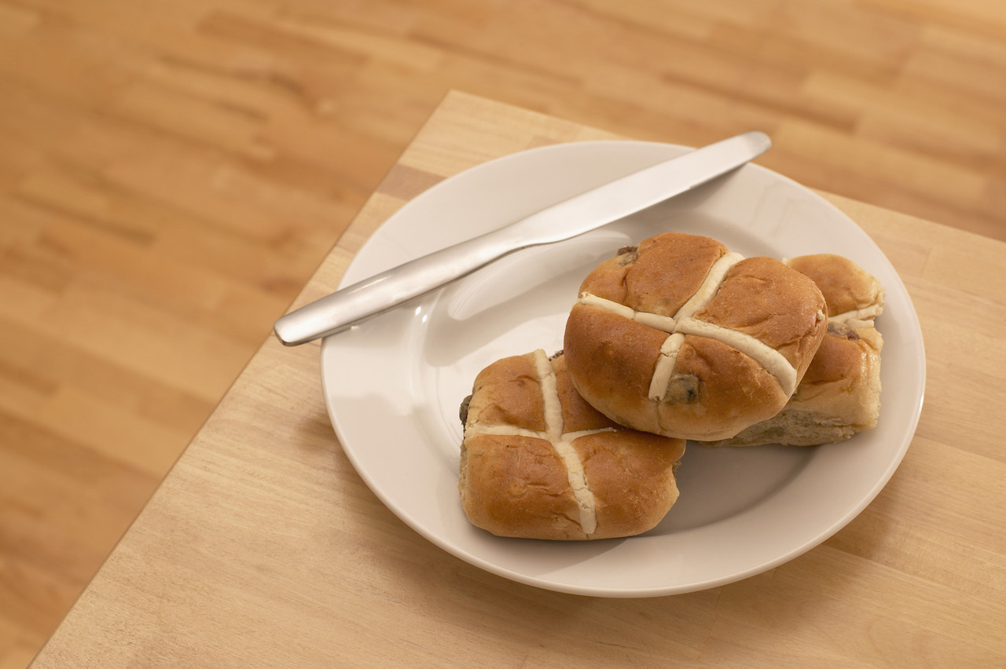
- An optional extra item – like a teacake, a few slices of malt loaf or banana bread, a scone or waffle, or maybe some home-made sugar free jelly made with fruit pieces and natural fruit juice, or a slice of fruit loaf

A note on portion size – a child’s portion of vegetables/ fruit/ potatoes etc... should fit into the palm of their hand. Remember that a child’s tummy is only the size of their fist.

Limit sugary puddings and use the sugar checker app from Change4life to help you find low sugar options for items such as Fromage Frais

Below is an example of the kinds of lunch boxes you might choose to send in across a week including a few more ideas of things to include in your child’s lunch box...

Ham and tomato sandwich  Fruit Fromage frais  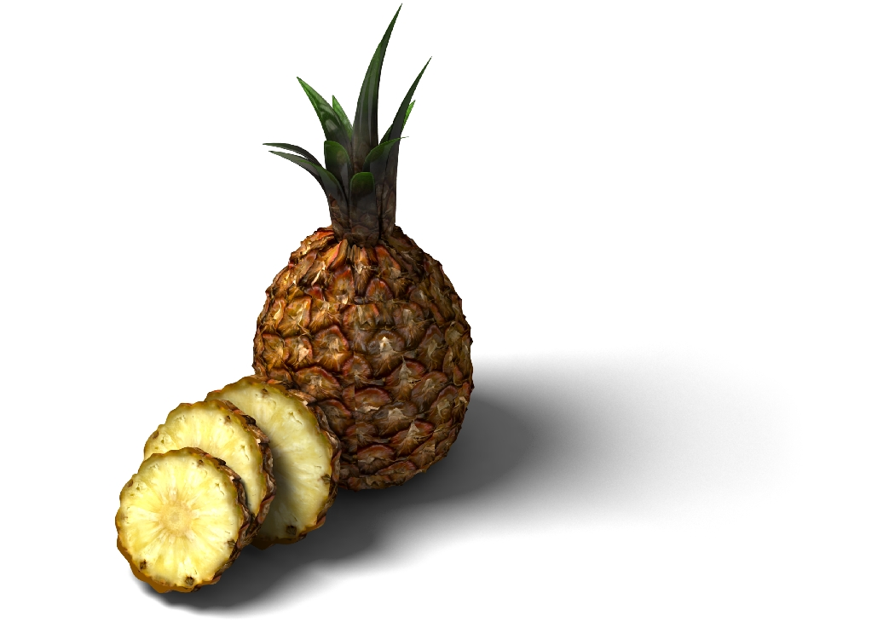  Handful of grapes (Chopped in half)  Slice of banana bread | Tuna and pasta salad: canned tinned tuna, chopped peppers with a little olive oil and lemon juice  Banana  Handful of raisins    Slice of home-made flapjack  Carton of milk
Mini pitta breads with hummus and grated carrot  Cubes of cheese    Handful of strawberries or cubes of melon  Fun-sized chocolate biscuit bar | Granary roll with canned salmon and cucumber slices  Sticks of red and yellow pepper  Small hand sized packet of crisps.  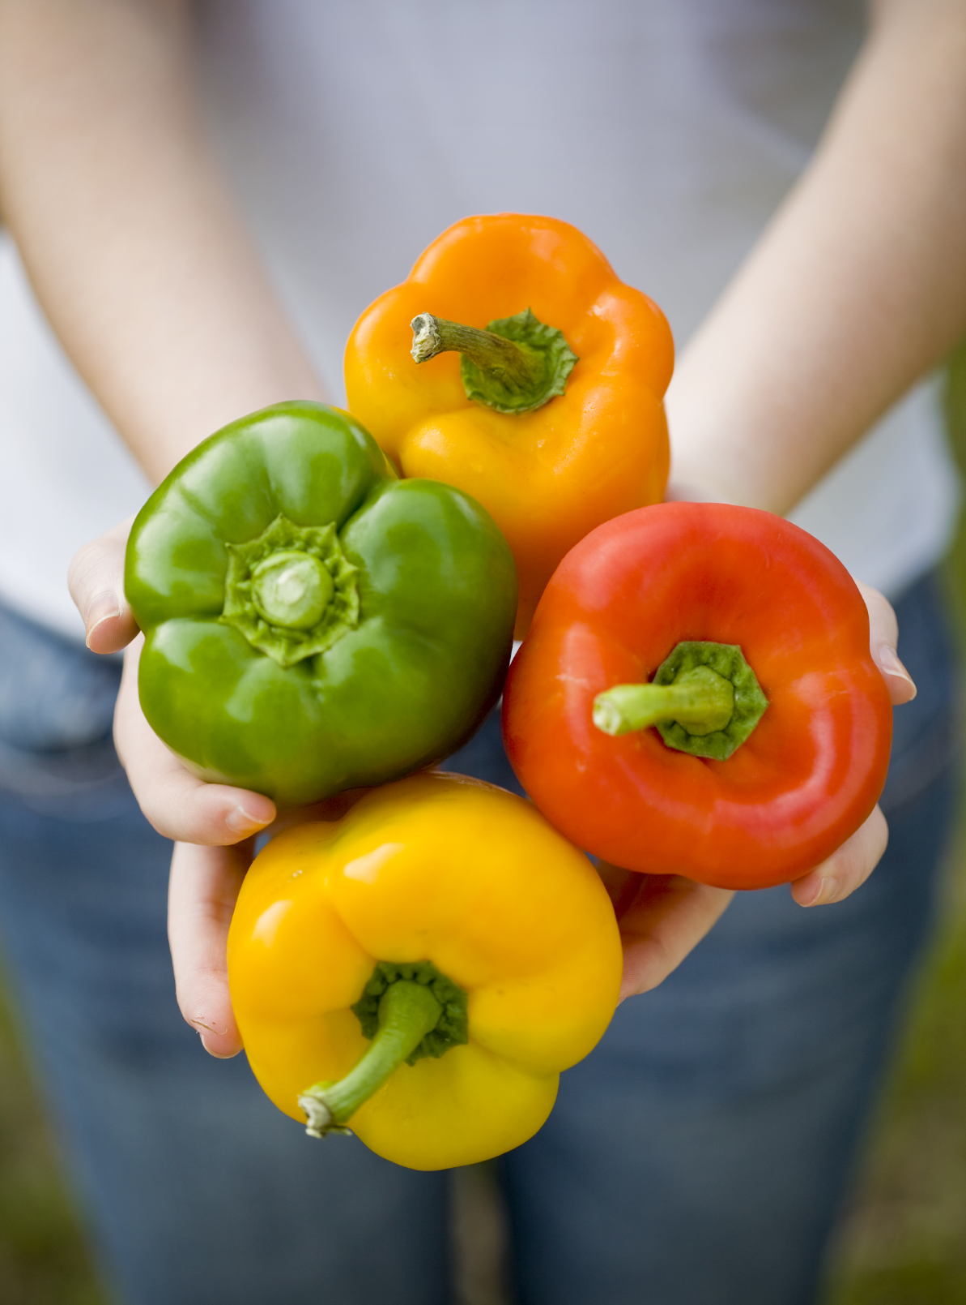  Peach or nectarine (sliced for little ones)  Carton of milk
  Cold Pasta salad with cooled/cold grilled sausage, chopped peppers and tomato pasta sauce  Carrot sticks  Small tub of fruit cocktail in natural juice  2 small chocolate chip cookies  Carton of milk | 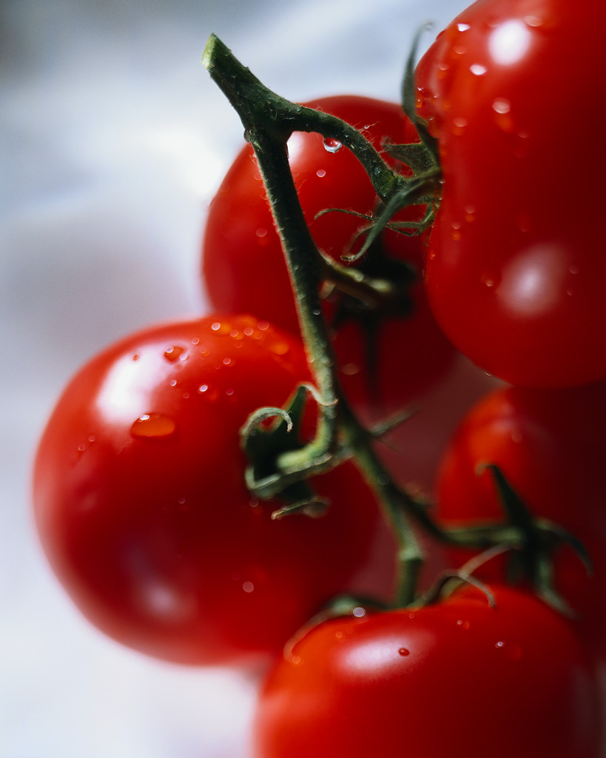  Chilled Lentil curry (or dhal) with chapatti  Cherry tomatoes (halved)  Fruit yoghurt  Slice of malt loaf

Please remember that all lunch boxes must follow the nursery’s Healthy Lunch Box Policy.

If you would like more information on how to support your child or toddler to eat healthily, please ask a member of staff for our tips sheet.

For recipes and other healthy food tips check out these great sites:

https://www.phunkyfoods.co.uk/recipes/
https://www.henry.org.uk/recipes
https://www.nhs.uk/change4life

