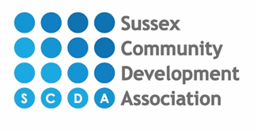
Affordable Counselling Service
Our fees for counselling sessions start at £20 per session depending on what the client is able to afford, based on the following income thresholds:
Income from employment | Cost per session
£20,000 | £20
£25,000 or less | £25
£30,000 or less | £30
£35,000 plus | £35

We have a limited fund to provide reduced cost sessions for those who need extra financial help and who can provide evidence of low income. Clients who need to access this fund will need to provide evidence of the following –
- Income support
- Income based Jobseekers allowance
- Income-related Employment Support Allowance
- Support under part 6 of the Immigration and Asylum Act 1999
- Guaranteed element of Pension Credit
- An income of less than £20,000 per year
All payment will be discussed and agreed at assessment with the coordinator. All counselling sessions require payment before each session. We may ask for evidence of income when agreeing the cost of counselling.

