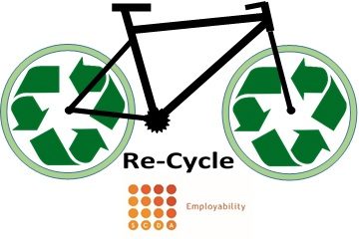
ROLE DESCRIPTION: VOLUNTEER BIKE MAINTENANCE TECHNICIAN
Reporting to the GSA Client Advisor
Summary: The Volunteer Bike Maintenance Technician will support the Client Advisor to refurbish donated bikes in need of repair. This is carried out in our Denton Island workshop. All refurbished bikes are sold back to the community in the SCDA charity shops based in Newhaven and Lewes.
Main duties and responsibilities may include
- Identifying repairs needed
- Carrying out repairs
- Stripping down bikes to recycle parts
- Cleaning, degreasing and lubricating bike parts
Requirements
- Able to use hand tools
- Previous experience would be desirable but all ability levels welcome
- Respect and maintain confidentiality of SCDA, clients and other volunteers

Training & Supervision
You will be provided with an induction and training to help you in the role. You will have regular supervision to help you get the most from the role.
- SCDA volunteer induction
- Practical work experience
- Participation in creating a social enterprise.
- Any other training suitable to the role

What we can give to you
- Opportunity to learn new manual skills
- Opportunity to support local community development
- Chance to support other local people
- Prevent landfill through recycle unwanted bikes

To find out more please contact George Stonehouse – 01273 516347
george.stonehouse@sussexcommunity.org.uk

