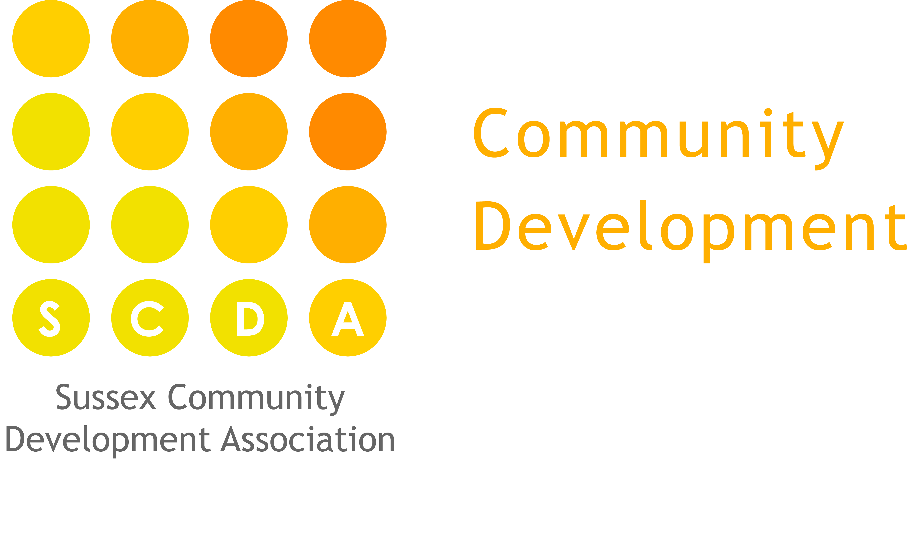

Risky Play Policy
‘Children and young people need to encounter some real risks if they are to respond positively to challenging situations and learn how to deal with uncertainty. This cannot be achieved by limiting them to supposedly safe environments.’
Play England, (2013) Philip Wolmuth

‘Risk underpins creativity, imaginative and scientific thinking’
Helen Touvey ‘all about risk’ (2014) Nursery World

Statement
At Denton Island Nursery we believe that even very young children need to encounter challenge and risky play opportunities in order to learn how to manage their own risk taking, keep themselves safe and learn about their own strengths.
Risk is part of life and when viewed in context of potential rewards and benefits we can see that risk can be part of the learning process; being about having a go at something new, being adventurous and gaining new learning experiences.
Research is showing that where children experience risk and challenge within a supportive environment there are benefits for their emotional well-being, their resilience and their mental health.
‘Children would never learn to walk, climb stairs or ride a bike unless they were strongly motivated to respond to challenges involving a risk of injury.’ (Managing risk in play provisions: A policy statement, 2002). While there may be a few bumps and tumbles along the way, this is all part of how children learn to master their physical skills, develop their self-esteem and sense of self-worth.
Aim
We aim to:-
- Provide a challenging and stimulating environment in which children are able to encounter developmentally appropriate risks through which their learning and development is promoted and enriched.
- Identify and control hazards and risks to ensure that children are never exposed to an unacceptable level of risk.

Methods
Denton Island Nursery will work to meet these aims by:-
- Drawing from both the EYFS and the National Children’s Bureau (NBC) publication’s by Play England’s Play Safety Forum to create policy and inform good practice.
- Using the ‘risks-benefits’ assessment framework identified in ‘Managing risk in play provisions’ by the NCB which focuses on ‘making judgments about the risk and benefits associated with an activity and the measure that should be in place to manage the risks while ensuring the benefits.’
- Having clear systems for identifying hazards and risks through the risk assessment procedure and using the risk-benefits system to then create and inform ‘technical inspections’ (e.g. equipment checks and routine checklists)
- Having clear and comprehensive guidelines for staff drawing on recognised good practice advice.
- Having confident and well trained staff who use the risk-benefits analysis and their own common sense to perform ‘dynamic assessment’ throughout the day, modifying activities, removing identified high hazards and being on hand to offer support when needed and a round of applause when a child achieves their goal, thereby promoting both physical and emotional well-being..
- Use of the key-person system through which close adult-child relationships are developed thereby enabling staff to both provided challenging opportunities and support children’s self-directed risky play.

Sources and further reading:

- Managing risk in play provision: Implementation guide (2013). Play England: Play Safety Forum. National Children’s Bureau. Second edition

- Managing risk in play provisions: A policy statement, (2002). Play England: Play Safety Forum. National Children’s Bureau.

- ‘All about Risk’ Nursery World (13-16 January 2014)

- Statutory framework for the Early Years Foundation Stage (2014) Department for Education.

