
Denton Island Nursery
SCDA Ltd
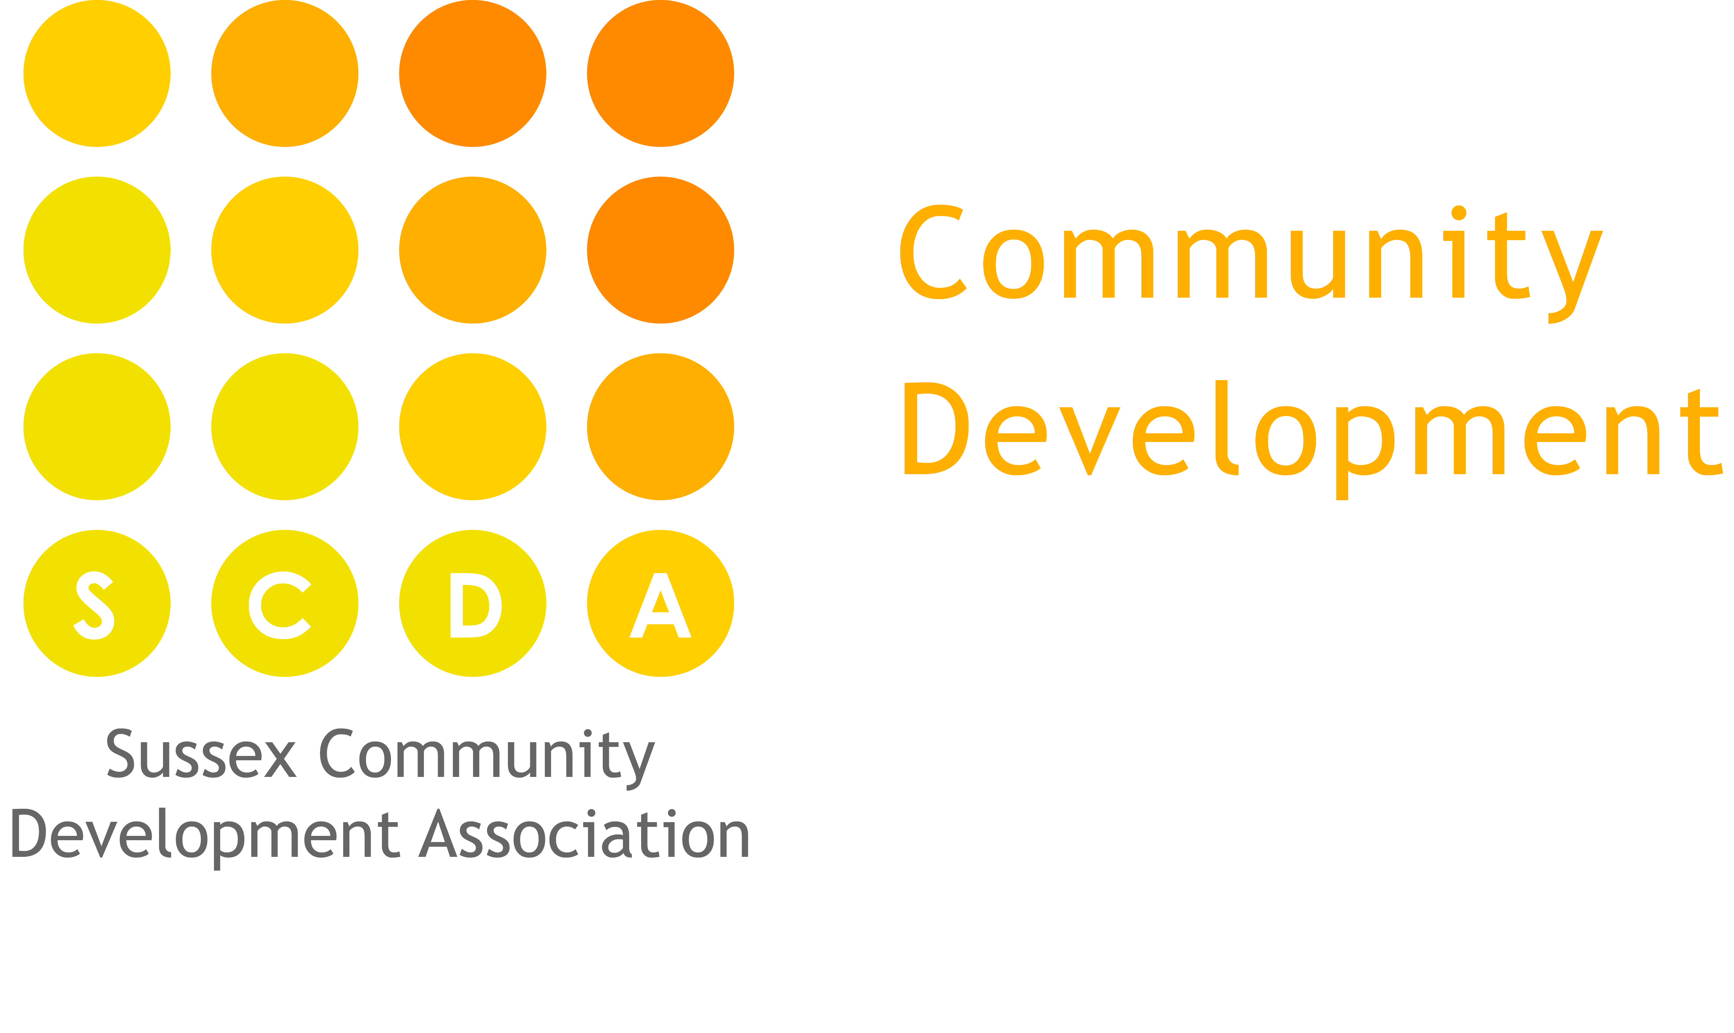

Key-person Policy
Aim
The emotional well-being of a child is vitally important and Denton Island Nursery recognises that it is essential that children feel safe, secure and supported in order to enable them to learn, grow and express themselves as unique and valued individuals.

Methods
In order to achieve this we:
- Ensure every child has a key-person to help them settle, meet their physical care needs, and plan and provide for their learning and development.
- Have a secondary key-person who will take the lead when the child’s primary key-person is not at nursery
- Offer an individually tailored settle-in time to help children and their families become familiar with the nursery
The child’s key person will:
- Work to build a trusting relationship with the child and their parents/ carers through honest, open and respectful dialogue and a supportive and friendly manner
- Meet the personal care needs of their key children, from nappies to feeding times. Building children’s feeling of self-worth and self-esteem by creating un-hurried and personalised one-to-one times.
- Support each child to become confident and independent in the setting.
- Insure each child’s needs and interests are met in the planning
- Support each child’s play and discovery. Extending their explorations and offering sensitive feedback
- Gather observations, photographs and keep each child’s Tapestry Learning Journey up-to-date
- Feed back to parents at the end of the session, maintaining the two way flow of information begun during the settling-in process.
- Liaise with any additional setting’s a child attends in order to provide consistence of care.
- Support each child at times of transition.
- Follow the Nursery’s ‘guidelines for key-person’s’ and other related policies and procedures.

