
Denton Island Nursery
SCDA Ltd

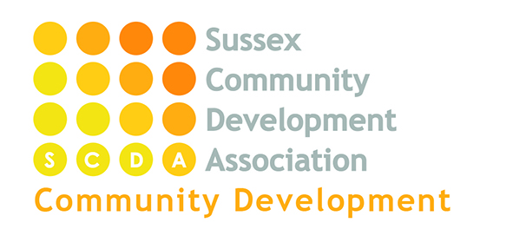
Healthy Lunch Box Policy
Aim
- To ensure all lunch boxes provided by children’s parents/carers contain healthy and nutritionally balanced foods
- To support parents/carers to understand the importance of establishing healthy eating patterns in their children from a young age
- To ensure that lunch boxes do not contain peanut or peanut based products
Statement
A healthy lunch box should include:
- An ice-pack.
- A minimum of one portion of fruit or vegetables per day
- A source of protein, such as meat, fish, lentils, kidney beans, chickpeas, hummus, falafel
- A source of dairy, such as milk, cheese, yogurt, fromage frais, custard
It is the nursery’s policy that sweets, chocolate bars, fizzy, or squash drinks and fruit juice and smoothies should not be included in children’s lunch boxes following healthy eating and best practice guidance.

In addition due to the risk of allergic reactions we ask that no peanut or peanut based products are included in children’s lunch boxes.

Methods
In order to support families to provide healthy, balanced and nutritious lunchbox meals we provide a variety of information on recipes and other food and drink related topics in addition, the following websites provide helpful recipes for children’s lunchboxes as well as great tools around healthy eating and lifestyles:-
https://www.phunkyfoods.co.uk/recipes/
https://www.henry.org.uk/recipes
https://www.nhs.uk/change4life

