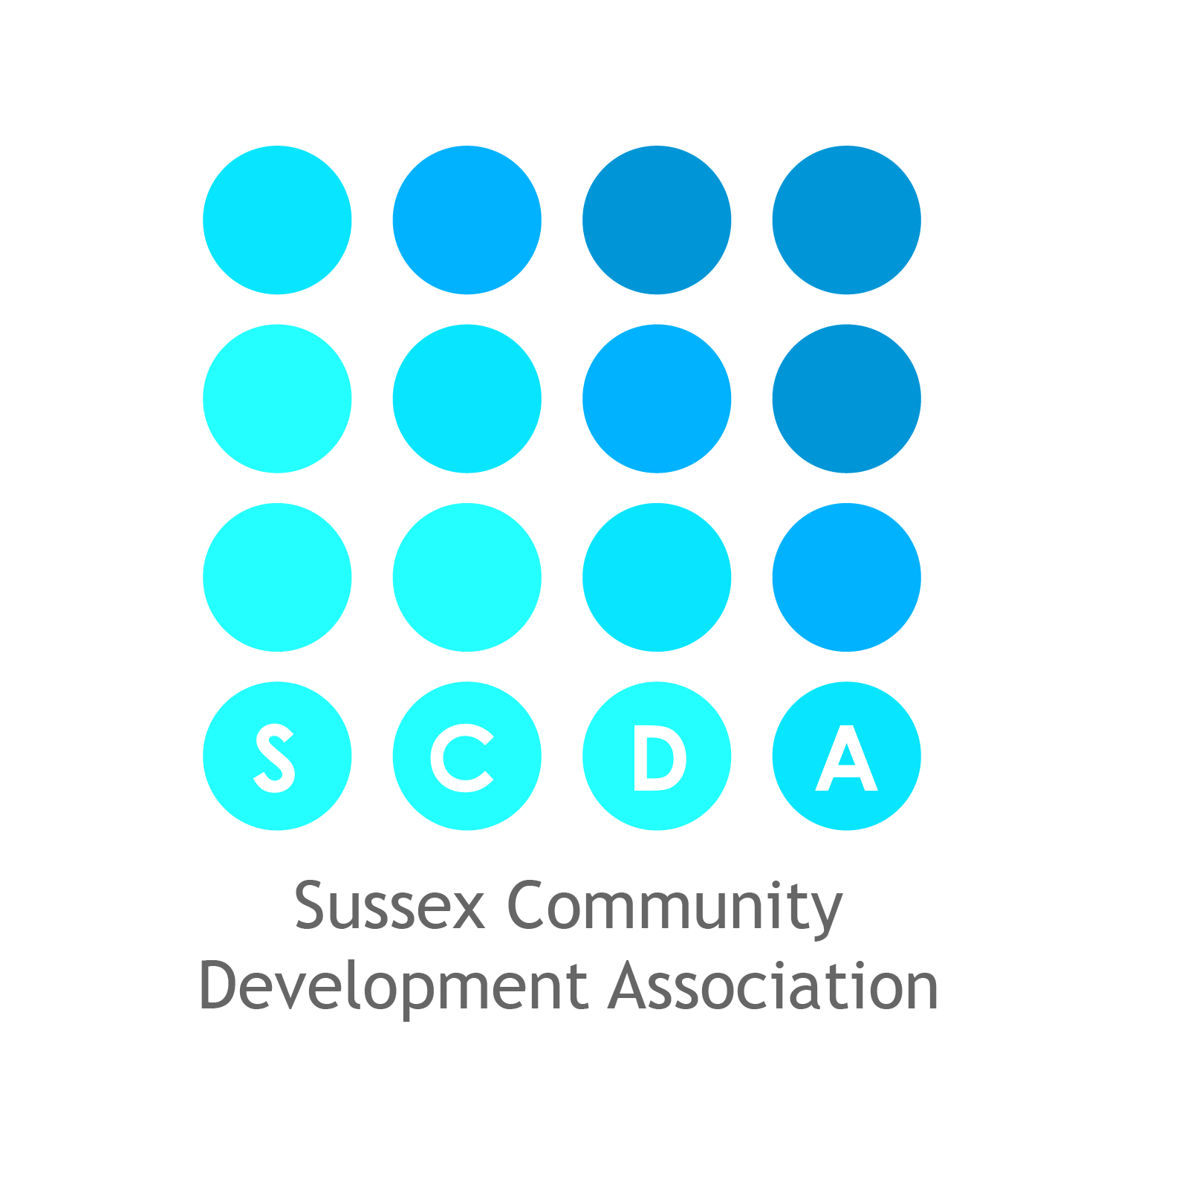
Equal opportunities monitoring form

This form will not be used during the short listing process but will be used separately and for the purpose of recruitment monitoring and provision of statistical data. All information supplied will be treated in the strictest confidence.

Post applied for: | Location of post:

Please tick the appropriate boxes

Sex | Female Male Prefer not to say  Other Please specify …………………………………………………………………….
Have you ever identified as transgender? | Yes | No | Prefer not to say
Age | 16 – 24 25 – 29 30 – 34 35 – 39  40 – 44 45 – 49 50 – 54 55 – 59  60 – 64 65 – 69 70 – 74 75+
Sexual orientation | Bisexual Gay man Lesbian/gay woman  Heterosexual/straight Prefer not to say

Do you consider yourself to have a disability?

Yes No Prefer not to say

A disability is an impairment that has (or is likely to have) a substantial (more than minor), adverse, long-term (more than a year) effect on the ability to carry out normal day-to-day activities.

What is the effect or impact of your disability on your ability to give your best at work? …………………….
……………………………………………………………………………………………………………………………………………………………………………………………………………………………………………………

The information in this form is for monitoring purposes only. If you believe you require a ‘reasonable adjustment’ at interview or during employment, please discuss this with the recruiting manager or with HR.

Ethnicity

Ethnic origin is not about nationality, place of birth or citizenship. It is about the group to which you perceive you belong.

Asian / Asian British

Indian Pakistani Bangladeshi Chinese

Other Asian background please specify ……………………………………………

Mixed / multiple ethnicity

White and black Caribbean White and black African White and Asian

Other Mixed background please specify ……………………………………………

Black / African / Caribbean / Black British

Caribbean African Somali

Other Black background please specify ……………………………………………

White

British English Welsh Scottish Northern Irish Irish

Gypsy or Irish Traveller Other white background please specify ……………………………………………

Other

Any other ethnic or national group please specify ……………………………………………

Prefer not to say

Religion, Faith or Belief

No religion or belief Buddhist Christian Hindu Jewish Muslim

Sikh Prefer not to say

Other religion, faith or belief please specify ……………………………………………

