
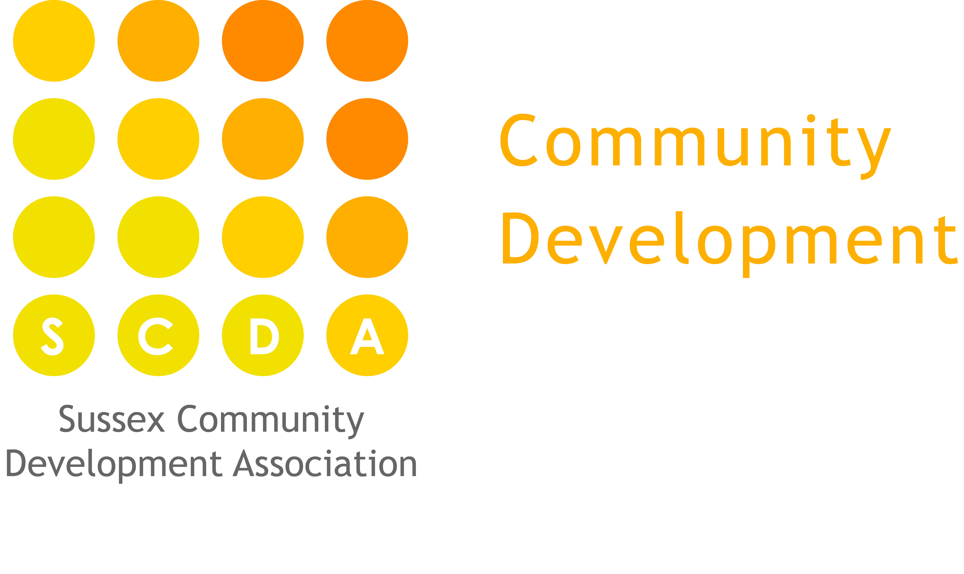
Denton Island Nursery
SCDA Ltd

Confidentiality policy

Statement of intent
It is our intention to respect the privacy of children and their parents and carers, while ensuring that they access high quality Nursery care and education.

Aim
We aim to ensure that all parents and carers can share their information in confidence that it will only be used to enhance the welfare of their children. Our Privacy Notice supports parents/carers to understand how their data and that of their children is used by Denton Island Nursery and SCDA.

Basic Principles for Confidentiality
- Justify the purpose for using confidential information
- Only use it when necessary
- Use the minimum that is required
- Access should be on a strict need to know basis
- Everyone must understand her or his responsibilities
- Understand and comply with the law
- A written request must be made before personal files can be released.
- Denton Island Nursery will take into account data protection rules that refer to third parties.

Personal data
Personal data is information about a living individual, who is identifiable by the information, or who could be identified by the information combined with other data.

This includes information such as; names, addresses, attendance records, ethnic origin, qualifications, experience, details about sickness or medical conditions, dates of birth, marital status, religion or beliefs, etc... It also includes recorded opinions about or intentions regarding a person. All such information comes under our confidentiality policy.

Sensitive personal data
Under our responsibilities for record keeping Denton Island Nursery may collect Sensitive Personal Data about children and their families, such as ethnic origin, religious or other belief, physical or mental health information, necessary to provide high quality care and education for the child. It is important to note that such information is considered to be especially sensitive under the data protection act, and as such must be given extra attention to ensure confidentiality.

Practices and Procedures
At Denton Island Nursery, we adhere to the Data Protection Act 1998; our privacy notice is displayed on the welcome notice board in the nursery hallway and data protection principles form parts of our nursery policies and procedures located in the Nursery Policy files (please see below for more details). The SCDA Data Protection Policy is the overarching policy which incorporates the Denton Island Nursery’s policy on confidentiality.

To ensure staff can follow these principles with confidence, we respect confidentiality in the following ways.

- Parents have ready access to the files and records of their own children but do not have access to information about any other child.
- Staff will not discuss personal information given by parents with other members of staff, except where it affects planning for, and the support of, the child's needs. Staff induction includes an awareness of the importance of confidentiality in the role of the key person.
- Any concerns/evidence relating to a child's personal safety are kept in a secure, lockable confidential file in a lockable cabinet and are shared with as few people as possible on a "need-to-know" basis.
- Personal information about children, families and staff is kept securely in a lockable file whilst remaining as accessible as possible.
- Issues to do with the employment of staff, whether paid or unpaid, remain confidential to the people directly involved with making personnel decisions.
- Students on Denton Island Nursery who are attending training courses or other recognised qualifications and training, are aware that when they are observing in Denton Island Nursery, they are advised of our confidentiality policy and we request that they document with us that this has been read and are required to respect it.
- Volunteers at Denton Island nursery are also made aware of their responsibilities for maintaining confidentiality through our induction processes.

Denton Island Nursery is obliged by Ofsted to collect certain personal data and Ofsted may request certain data as part of their duties and responsibilities to the Department for Education. If a parent/carer would like any further information on the kinds of data Ofsted may request please refer them the information line: 0300 123 1231 as displayed on the hallway notice board. Our Privacy Notice also contains contact information for parents/carers information.

We also have certain obligations regarding information sharing under the Local Safeguarding Children Board as outlined in SCDA’s overarching Safeguarding policy and Denton Island Nursery’s Safeguarding and Child Protection Policy and our ‘whoops forms – why we need to ask about bumps and bruises’.

Photographs and video images
At Denton Island Nursery we use photographs and video footage to capture children’s learning and development. These photographs and video footage are used in children’s Learning Journeys and in displays around the Nursery. All parents/carers sign a permission form allowing us to take photographs of their children for this purpose.

From time to time photographs or videos are planned to be taken for other purposes, i.e. for publicity or marketing. SCDA has a permission form for parents/carers to sign on behalf of their children, and one for themselves if relevant, that is completed prior to any such event.

All staff must be aware that pictures and video footage of children are considered ‘Personal Information’ and as such come under the confidentiality guidance and must be protected from misuse. Photographs and video footage of children are kept on password protected computers (these passwords are changed every 6 months) located in areas where parents/carers do not have access. Files of photographs do not contain the child’s name or any other information. Digital images of children must not be removed from the premises by any staff member.

When Digital images of children are saved on disc the disc must be stored in a secure lockable cabinet within the manager’s office and not left in the staff room. These could be images of for example the gardening grand opening, evidence of other celebrations within the nursery and Community Centre. All images will be removed when the child no longer attends the nursery.

Mobile phones with cameras are not permitted in the nursery rooms and must be kept in staffs lockers. Parents/carers are asked not to use their mobile phones inside the nursery when on the premises. Personal cameras should not used in the nursery. Please see our mobile phone policy for more details.

Security of information when taken outside of the nursery
Staff must not remove children (or their families) personal data from the nursery. As part of the nursery’s snow policy staff may be given work to take which is of a non-confidential nature. Staff should ensure that they take all reasonable steps to ensure the security of such information to prevent loss, theft or damage.

Social Networking Sites
Please see the SCDA’s and the nursery’s Social Networking site policy for details of how the confidentiality policy applies here.

Other policies
The Confidentiality Policy focuses on how Denton Island Nursery collects and uses personal data for children and their families. We also issue all parents/carers with a Privacy Notice detailing what kinds of personal information the Nursery holds on their children and to what use they put it. This notice is given to parent/carers in our welcome pack and is also available in our policies and procedures file in the Nursery managers office, on display on the welcome board and on our website.

SCDA has a data protection policy which Denton Island Nursery follows regarding the uses of client’s and employee data. This policy is located in the staff room policy file.

The staffing and employment policy also has information about how Denton Island Nursery collects and uses personal data as part of the recruitment processes.

Request for personal data

Under the data protection act individuals are able to make a request to see any personal data held about them, or to make this request on behalf of their child. Any request to access such personal data will be replied to within the 40 day period set out in the Data Protection Act.

Please be aware that Denton Island Nursery has a duty to respect the right to confidentiality of any ‘third party’ whose personal data is also included in the personal data requested by an individual (for example if person A requests information containing their own personal data but this included data on person B).

It is important to note – The Courts can order disclosure of information.

Reporting incidents
If any member of staff is aware of a breach of confidentiality, that person must report the incident to the Nursery Manager. If the breach is serious and needs action immediately, the Nursery Manager or Deputy Manager’s should be contacted without delay.

The incident will then be investigated in a similar fashion to the complaints procedure and the perpetrator, if they can be identified, contacted by the Nursery Manager. It is then the responsibility of the Nursery Management Team and SCDA to decide if any action can be taken to remedy a further breach, or if disciplinary proceedings are necessary against a member of staff or third party that has been permitted access but has abused the privilege.

All staff must be aware of their personal responsibility to protect personal data under the Data Protection Act. They must also follow the ‘Procedures to ensure the safety and security of all personal data’. A breach of this responsibility may not only result in disciplinary action but could constitute a criminal offence.

All the undertakings above are subject to the paramount commitment of Denton Island Nursery, which is to the safety and well-being of the child. Please see also our policy on child protection and safeguarding policy.

