
Denton Island Nursery
SCDA Ltd

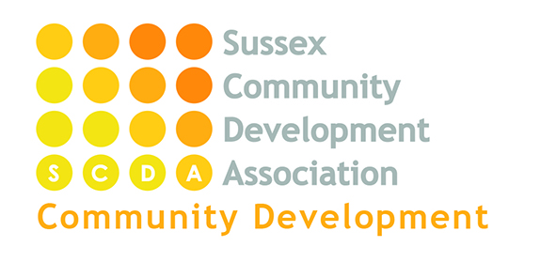

Funded Places Policy: 15 and 30 Hour packages

Statement of Intent
Denton Island Nursery is dedicated to offering high quality Early Education and Care to the local community in which it sits.
Funded places are designed to allow all families access to such provision, however;
“Government funding is intended to deliver 15 or 30 hours a week of free, high quality, flexible childcare. It is not intended to cover the cost of meals, other consumables, additional hours or additional services”
Early Education and Care Statutory Guidance for Local Authorities (March 2017)
The nursery currently offers funded places for qualifying two years and for all three years old for up to 15 hours a week and for those eligible up to 30 hours per week.

Aim
Our aim is to make these places available for families providing free access to the nursery’s educational and care provision within in a financially sustainable package.

The offer – Funded sessions from September 2018

Parents who wish to use only the funded hours with no additional sessions -term time only, the offer will be:

15 hours per week for 38 weeks per annum 1pm-4pm per day

30 hours per week for 38 weeks per annum 1pm-6pm per day
Plus, one morning 8am-1pm

Parents who wish to stretch the funded hours over the full year, the offer will be:

12 hours per week 47 weeks per annum 1pm-4pm per day

24 hours per week 47 weeks per annum 1pm-5pm per day
Plus, one morning 9pm-1pm

The new contract will cover 51 weeks and will be subject to 47 weeks having up to 24 hours of free childcare and a set 4 weeks where childcare is chargeable at full rate.
Parents can choose to access the nursery between the hours of 8am till 6pm with hours outside of the above funded session times being charged at full rate. There is a range of collection and pick up times listed below. Both Term Time and Full Year attendance includes a small charge for high quality meals provided by the nursery and our lunch provider Little Tums (see Exclusions below). Parents still have the option of providing their own lunch cold packed lunch if they wish too (complying with our Healthy Lunch Box Policy) rather than purchasing a hot meal at lunch. Healthy snacks are provided by the nursery.
Opening hours:
The nursery is open between 8:00am and 6:00pm with the following choices of start times;
Start times: 8:00; 8:30; 9:00 and 1:00.
Collection times: 12:00; 1:00; 3:00; 3:30; 4:00; 5:00; 6:00.
The variety of start and collection times will enable parents to tailor their child’s attendance to their family’s needs.
Children can attend all year round (children on free childcare hours can ‘stretch’ the funding to include all year provision) over 51 weeks and will be subject to 47 weeks having up to 24 hours of free childcare and a set 4 weeks where childcare is chargeable at full rate or attend only in school term time, 38 weeks across the year. Please see our Standard fee’s information for more details on stretching.

Session places are limited by nursery capacity. Priority of places will go to existing families first and then any new clients in line with our Admissions Policy and sessional availability.
Extra sessions.
Parents can purchase additional hours beyond their child’s funded sessions if they wish to. Our Standard Fees Information provided in our Prospectus lays out our registration and session fees information for parents wishing to purchase additional hours.

Exclusions
As mentioned above the funding provided by government does not include food or other items, our policy related to such additions are laid out below:
Consumables
The nursery asks all of our parents to provide their own consumables, such as nappies, wipes, sun creams etc. for the use of their child at nursery.
Food
For parents accessing our Enhanced Package or who are purchasing additional hours above their funded sessions, the nursery charges the following amount for Meals served from our Menu’s rated ‘Outstanding’ by the Children’s Food Trust:
Breakfast (served at 8:00): £1
Lunch (served at 12:00): £2.65 Hot Lunch
Tea (served at 5:00): £1
Snack (served during morning and afternoon sessions): Free
Parents can choose to provide their own packed lunch if they wish to rather than having a hot lunch provided by Little Tums. This lunch must be suitable to be served cold and must conform to our Healthy Lunch Box Policy.
Additional Services:
In the event the nursery offers outings, trips or special bought in sessions (e.g. Dance, sport, music or language sessions) these services may involve a charge to cover costs. Such sessions will be voluntary and parents can choose not to access them if they’d prefer.

Additional Information
The government’s funded session and the nursery’s offered packages will be subject to review and development over time. We will keep parents informed of any updates and changes to government or nursery policy related to the provision of free/funded child education and care places.

